**<<TOTR SHOP>>**

**Software Requirement Specification**

– HCM, Mar 2023 –

**Table of Contents**

I. Overview 3

1. Introduction 3

2. System Functions 4

3. Common Requirements 5

II. Functional Requirements 6

1. <<Feature Name 1>> 6

a. <<Function Name 1>> 6

b. <<Function Name 2>> 6

2. <<Feature Name 2>> 6

# Overview

## 1. Introduction

Shop Bán gaming gear ONLINE Cung cấp đầy đủ các chức năng hỗ trợ nhân viên, khách mua thực hiện các hoạt động bán, mua thuận tiện nhanh chóng hơn.

**\*Lưu trữ thông tin khách hàng, yêu cầu đăng nhập bằng tài khoản trước khi đặt hàng.**

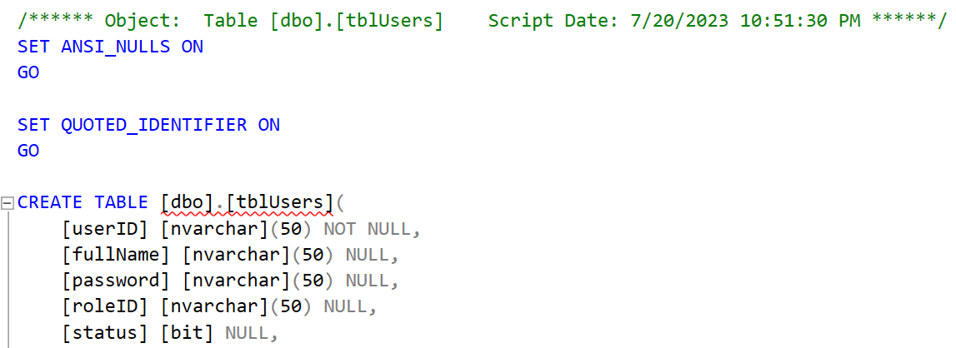

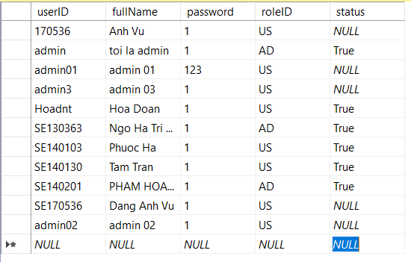

**\*Bảng Products.**

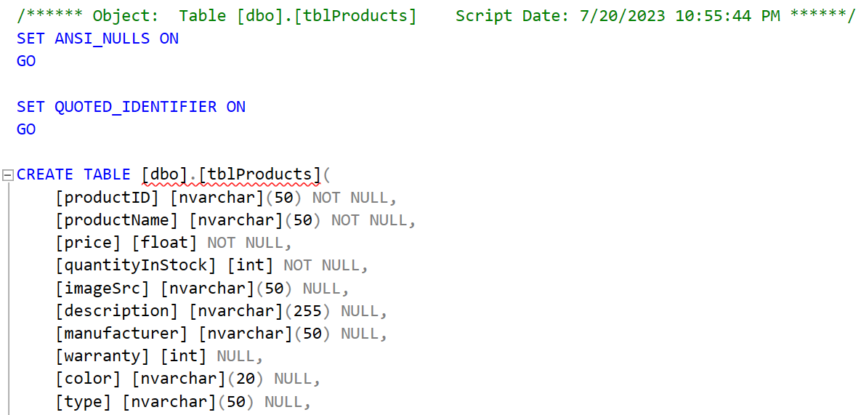

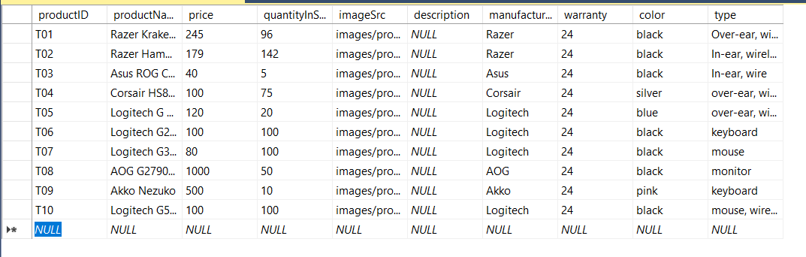

**\*Bảng Order.**

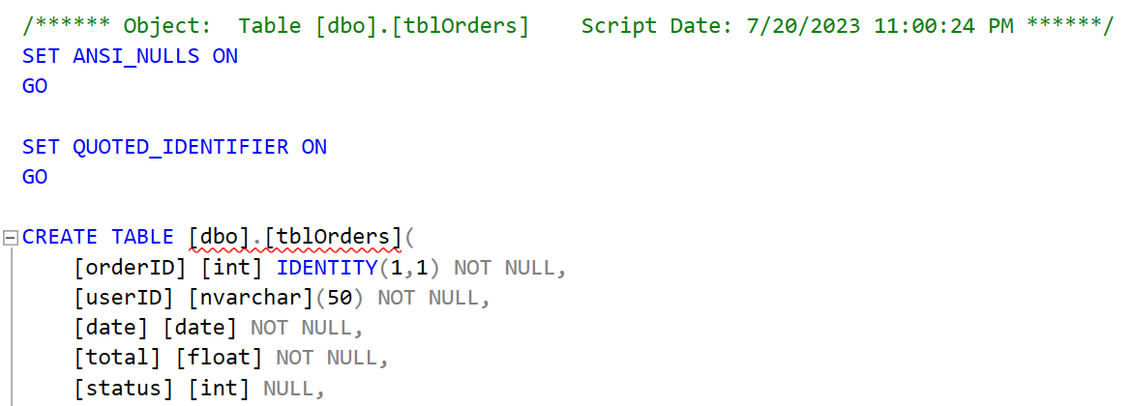

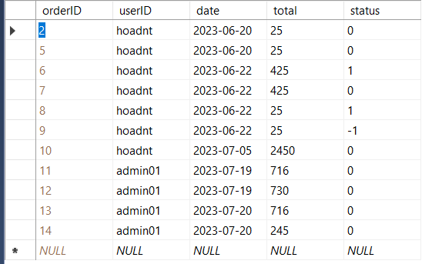

**\*Bảng OrderDetails.**

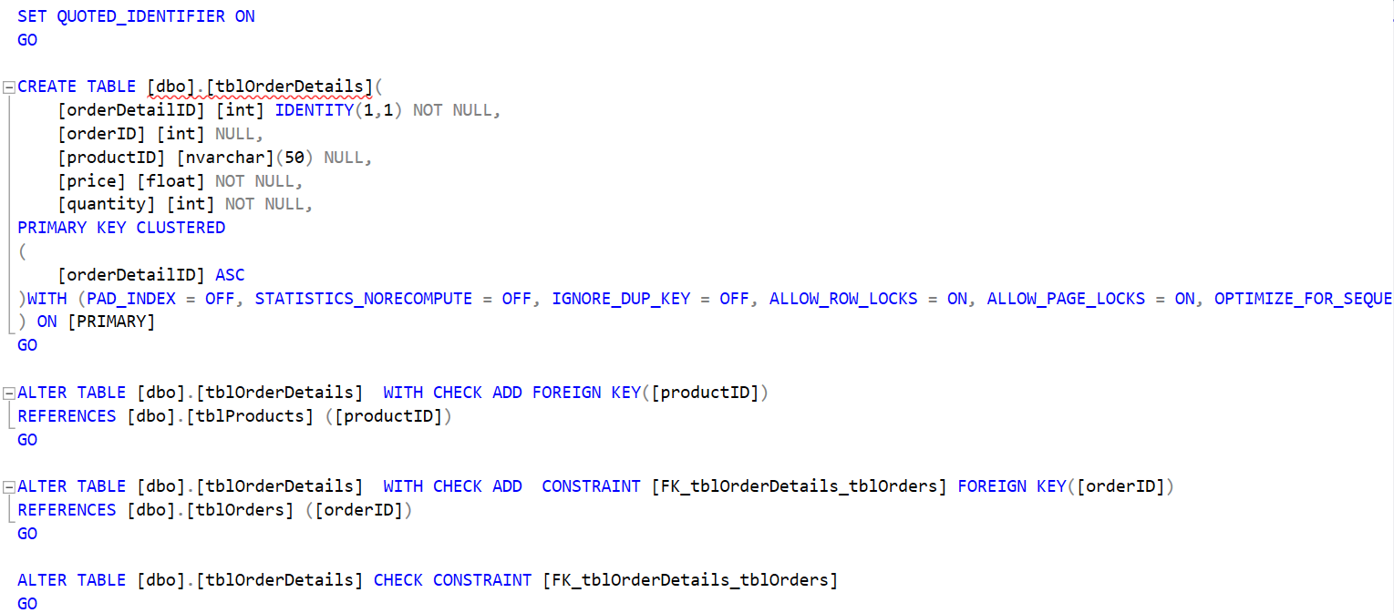

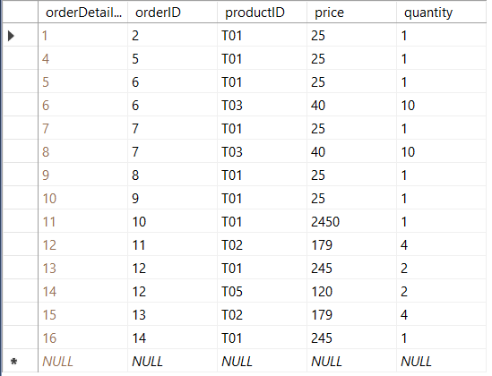

## System Functions

a. Screen Flow

#### 

b. Screen Details

*[Provide the descriptions for the screens in the Screens Flow above]*

***b.1 User Web Application***

|  |  |  |  |
| --- | --- | --- | --- |
| **#** | **Feature** | **Screen** | **Description** |
| 1 | Login account | Login page | Contains text box to input username and password, login button, register link |
| 2 | Register account | Register page | Contains text box to input user information, register button |
| 4 | Shopping | Shopping | Contains gears’ details and information, quantities textbox, add to cart button |
| 5 | Cart | View Cart | Display no of order & id, name, quantity ,total price of products  Remove products or edit quantity |
| 6 | Checkout | View Cart | Click button check out |
| 7 | View Order | Your Order | No, id, user, date, total price, status  Button to view order’s detail  Button to cancel order |

***b.2 Admin Web Application***

|  |  |  |  |
| --- | --- | --- | --- |
| **#** | **Feature** | **Screen** | **Description** |
| 1 | Login account | Login page | Contains text box to input username and password, login button, register link |
| 2 | Register account | Register page | Contains text box to input user information, register button |
| 4 | User | View Users | Contains all information of all users  Button to update Name/Role  Button to delete user |
| 5 | Order | View Orders | Display all orders’ information  Button to view detail  Button to cancel order  Button to change status of order |

# II. Functional Requirements

## 1. Login / Register

* Function trigger: after clicking login button or click the button to milk tea without logging in
* Function description: The system allows users to use their username and password to log in to the system as customer
* Screen layout:

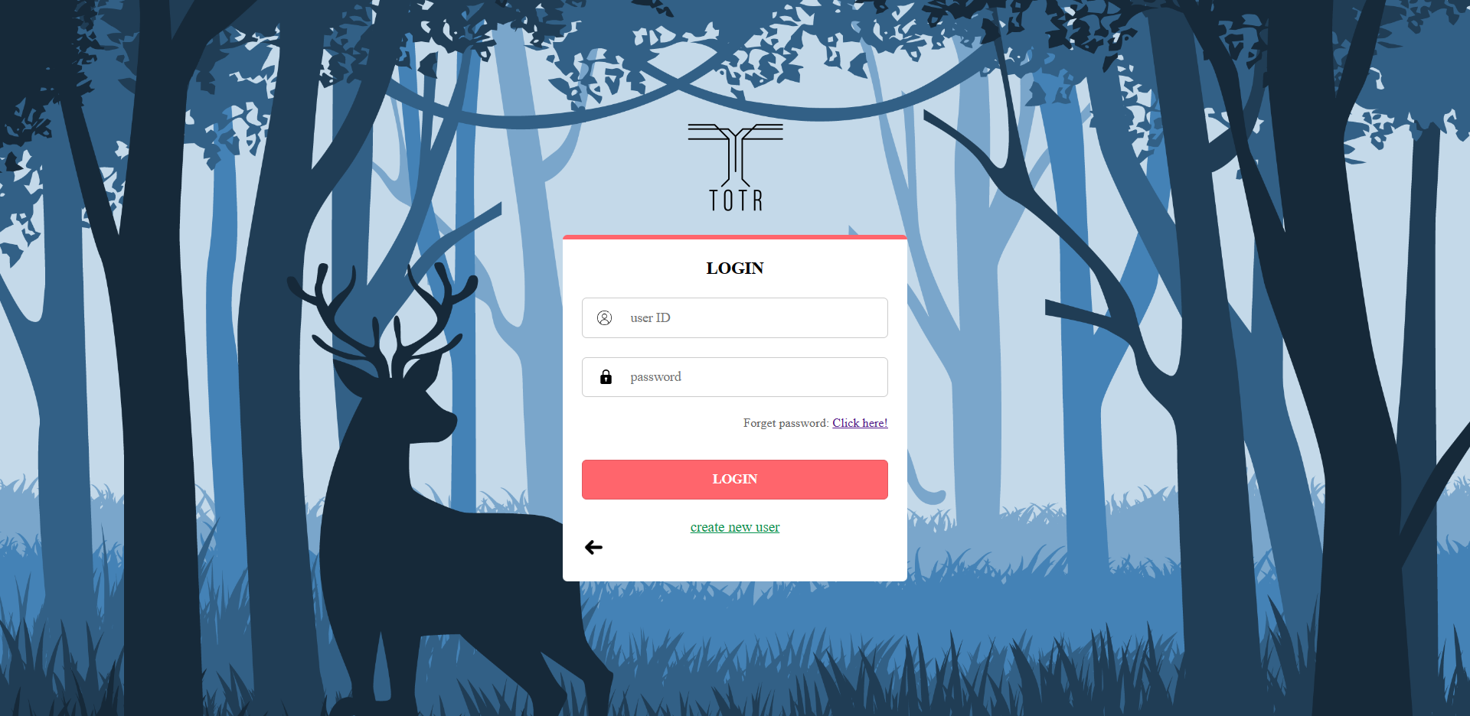

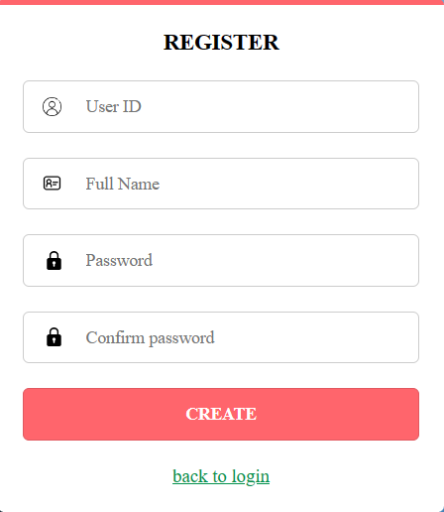

## 2. Welcome page

* Display user’s information

## 2. Shop page

* Function trigger: after the clicking “Shop”
* Function description: the system shows the shoppage for user
* Screen layout:

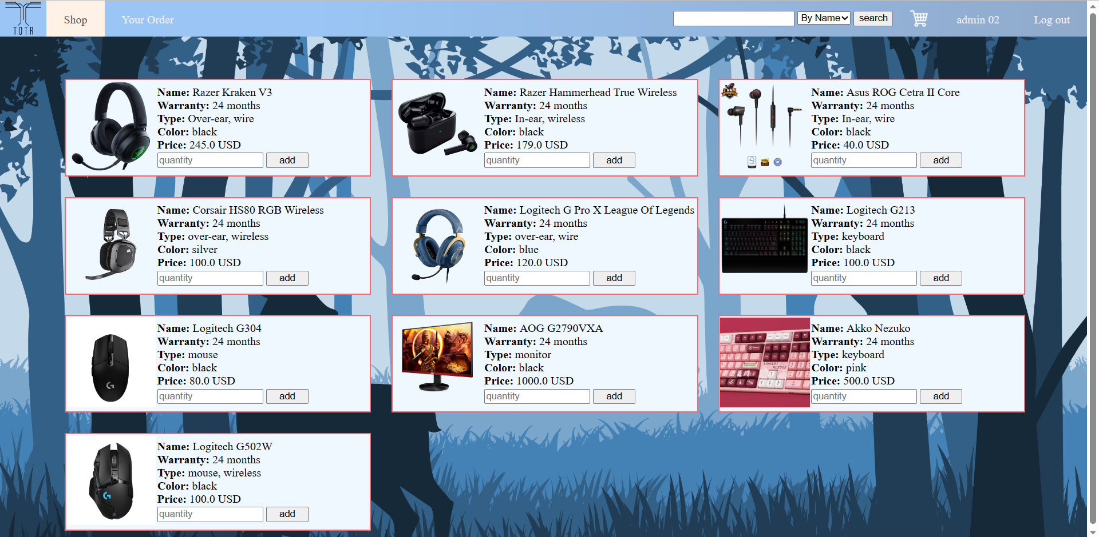

## 3. Show Products belong to type.

* Function trigger: after the filling input and clicking “Search” button
* Function description: the system shows list product (type or brand) for user
* Screen layout:

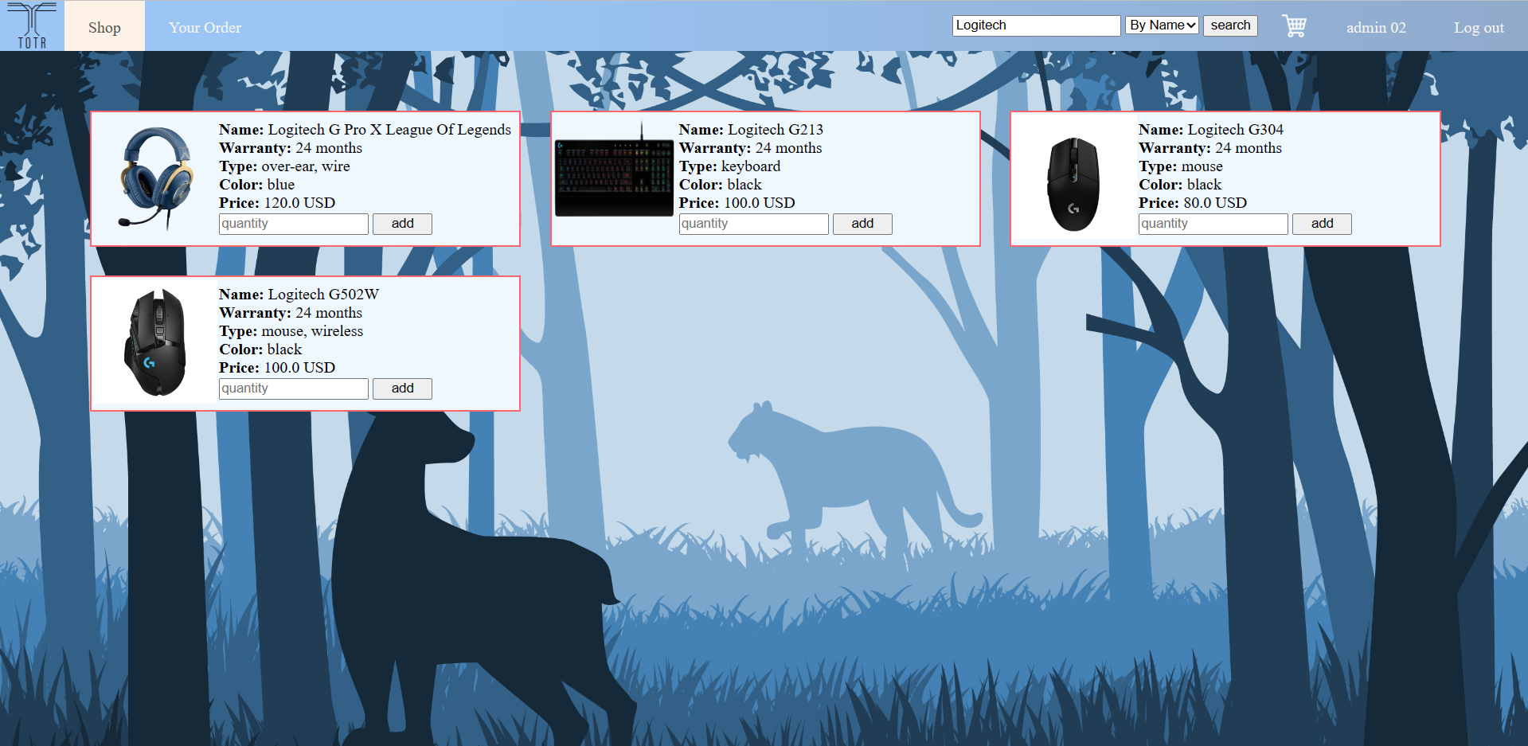

## 5. CART page.

* Function trigger: after the clicking “add” button in other page.
* Function description: product in cart(remove, edit), button to CheckOut.
* Screen layout:

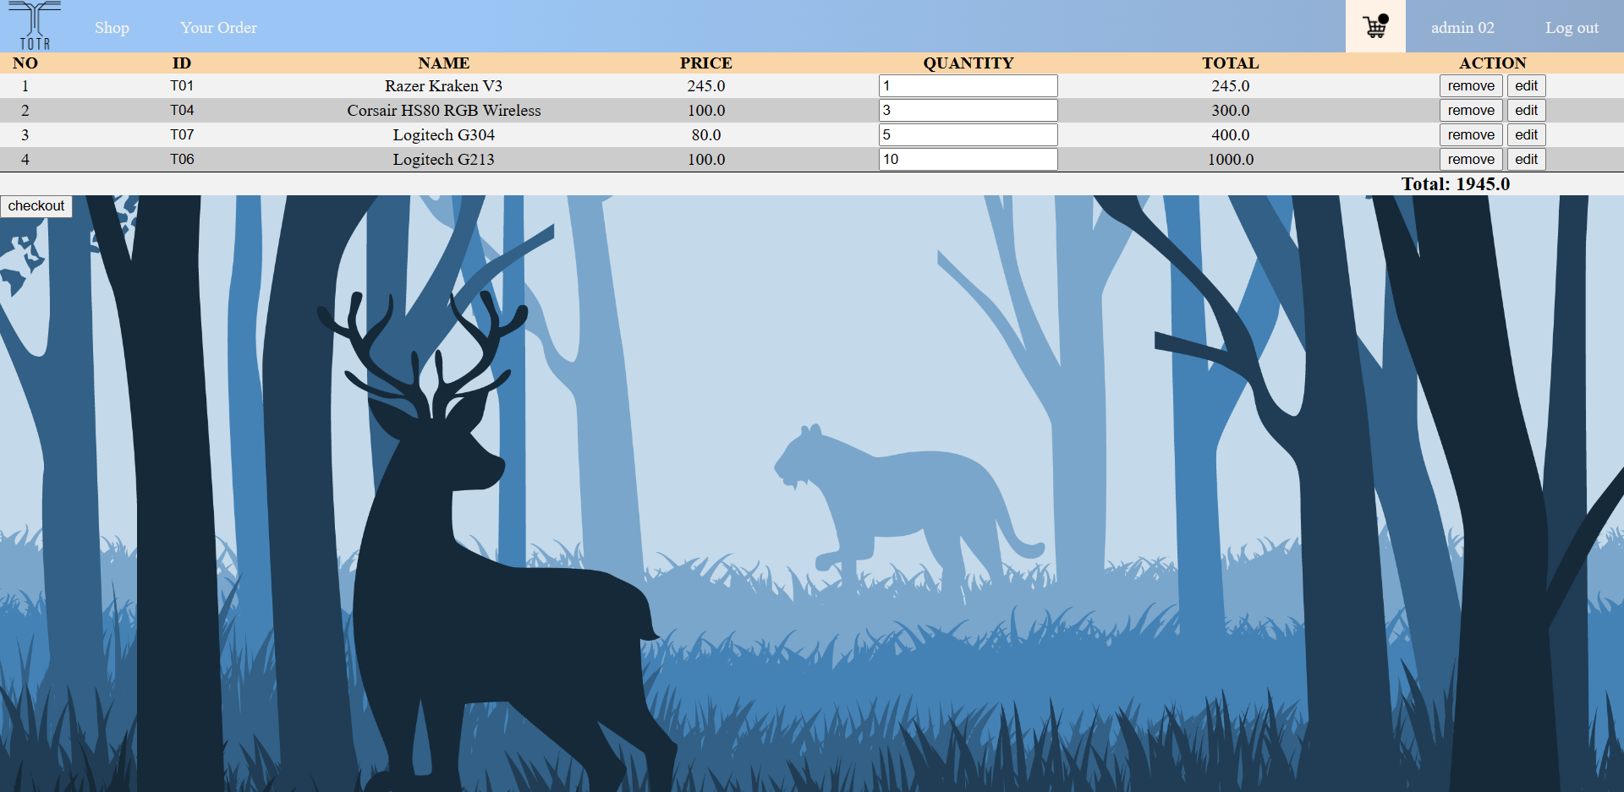

## 6. ORDER page.

* Function trigger: after the clicking “Checkout” button in cart page. Required login.
* Function description: order
* Screen layout:

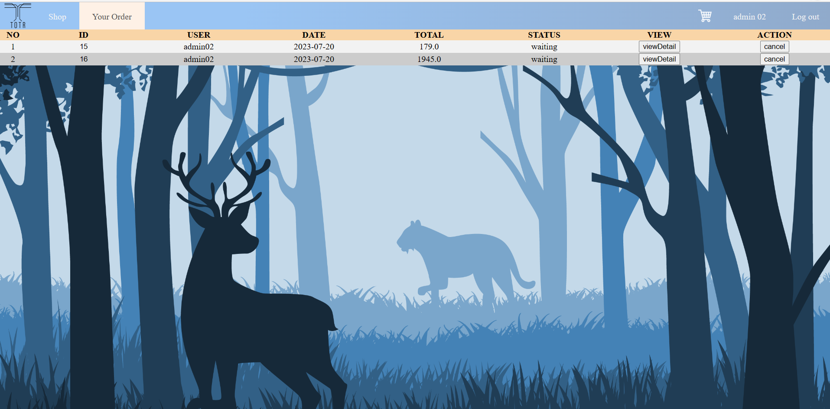

## 7. Admin page.

* Function trigger: after the login as admin account
* Function description: full controll
* Screen layout:

